H.T No
Regulations:
A22

Sreenidhi Institute of Science and Technology
(An Autonomous Institution)
Code No:9K201 Date: 09-August-2024 (FN)

B.Tech I-Year II- Semester External Examination, August-2024 (Regular & Supplementary)
ENGINEERING MECHANICS (CIVIL)

Time: 3 Hours Max.Marks:60

Note: a) No additional answer sheets will be provided.
b) All sub-parts of a question must be answered at one place only, otherwise it will not be valued.
c) Missing data can be assumed suitably.
Bloom's Cognitive Levels of Learning (BCLL)

Remember | L1 | Apply | L3 | Evaluate | L5
Understand | L2 | Analyze | L4 | Create | L6

Part - A Max.Marks: 6x2=12

Answer all QUESTIONS, EACH QUESTION CARRIES 2 MARKS.

 |  | BCLL | CO(s) | Marks
1 | Define the resultant of a force system | L1 | CO1 | [2M]
2 | Explain the laws of friction. | L2 | CO2 | [2M]
3 | Describe the centroid of simple figures from first principles. | L1 | CO3 | [2M]
4 | What is the moment of inertia for sector of a circle? | L1 | CO4 | [2M]
5 | Explain rectilinear motion. | L2 | CO5 | [2M]
6 | What is D’Alembert’s principle? | L2 | CO6 | [2M]

Part – B Max.Marks: 6x8=48
ANSWER ALL QUESTIONS. EACH QUESTION CARRIES 8 MARKS.

 |  | BCLL | CO(s) | Marks
7. | A system of connected flexible cable shown in Fig.3 is supporting two vertical forces 200 N and 250 N at points B and D. Determine the forces in various segments of the cable. [10 M]  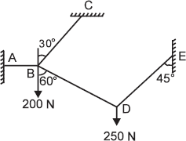 | L4 | CO1 | [8M]
 | OR
8 | a) Explain free body diagram with example. [5 M]  b) State and prove Lami’s theorem. | L2 | CO1 | [8M]
9. | State laws of friction and explain with suitable examples. | L2 | CO2 | [8M]
 | OR
10 | Find the least horizontal force P to start motion of any part of the system of three blocks resting upon one another as shown in figure. The weights of the blocks are W_{A} = 300 N, W_{B} = 100 N, and W_{C}= 200 N Between A and B µ = 0.3, between B and C µ = 0.2, and between C and the ground µ = 0.1.  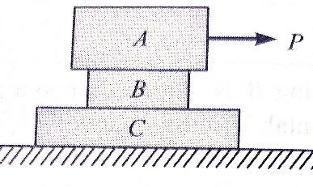 | L3 | CO2 | [8M]
11 | Consider a composite section made of a 3m wide, 0.2m high concrete slab on top of a steel I-beam with flange dimensions 0.3m x 0.02m, web dimensions 0.3m x 0.01m. Calculate the cross-sectional areas and centroids of the slab and I-beam, then determine the overall centroid of the composite section. Explain the practical importance of finding the centroid in building floor system design. | L3 | CO3 | [8M]
 | OR
12 | Locate the centroid of the T-section with width and depth of flange as 150 x 40mm and width , depth of web as 200 x 40mm. | L4 | CO3 | [8M]
13 | Determine the moment of inertia of the symmetrical I-section having top and bottom flange width and thickness as 200 x 20. And the web width the overall depth as 30 x 240. Also find the moment of inertia of the section about a centroid axis perpendicular to x-x and y-y axis. | L4 | CO4 | [8M]
 | OR
14 | i) Determine the moment of inertia of a circular about its diametral axis from the principles.  ii) Describe the method of finding out the moment of inertia of a composite section. | L1 | CO4 | [8M]
15 | Deduce the general expression to determine the maximum height and horizontal range of inclined projection. | L5 | CO5 | [8M]
 | OR
16 | Discuss Newton’s second law for polar coordinates | L2 | CO5 | [8M]
17 | Describe the types of motion and general principles in dynamics | L2 | CO6 | [8M]
 | OR
18 | Apply the work-energy principle to connected bodies. | L3 | CO6 | [8M]

-- 00 -- 00 –

